Cybersecurity Analyst Internship
Task Report

[samfelix15@gmail.com]
Task No: [20 - Cloud Security Basics]

Copyright © 2024 EncryptEdge Labs. All rights reserved
Credit: Offensive Security

Table of Contents
1.0 EncryptEdge Labs Internship Task Report 2
1.1 Introduction 3
1.2 Objective 4
1.3 Requirements 5
2.0 High-Level Summary 11
2.1 Recommendations 11
2.2 Risk exposure over time 12
3.0 Report - Methodologies 13
3.1 Information Gathering 14
4.0 Additionals Item X
1.0 EncryptEdge Labs Internship Task Report

1.1 Introduction
Cloud security has become a critical concern in today's digital age. With the rapid adoption of cloud computing, organizations are increasingly storing sensitive data and applications in the cloud. However, this shift to the cloud also brings new security challenges. Cloud security refers to the practices, technologies, and controls designed to protect cloud computing environments, data, and applications from cyber threats and vulnerabilities.
Cloud security is a set of policies, technologies, and controls designed to protect cloud computing environments, data, and applications from cyber threats and vulnerabilities. As organizations increasingly rely on cloud computing, understanding cloud security basics is crucial for safeguarding sensitive data and ensuring business continuity.
The history of cloud security emergence is closely tied to the evolution of cloud computing. As cloud computing has grown in popularity, so has the need for robust security measures to protect cloud-based assets. Today, cloud security is a top priority for organizations of all sizes, and it's essential to understand the challenges and best practices for securing cloud environments.

1.2 Objective
The objectives of cloud security are to:
1. Protect Cloud Data: Protect cloud data from unauthorized access, breaches, and other security threats.
2. Ensure Compliance: Ensure compliance with regulatory requirements and industry standards related to cloud security.
3. Prevent Data Loss: Prevent data loss and ensure business continuity in the event of a security incident.
4. Secure Cloud Applications: Secure cloud applications and services from vulnerabilities and threats.
To achieve these objectives, organizations must implement effective cloud security strategies and controls, including data encryption, access controls, and monitoring.
Based on my report, my main tasks and objectives are to,
- Understand the unique security challenges and considerations specific to AWS.
- Learn fundamental principles for securing AWS cloud environments.
- Gain hands-on experience by implementing security measures for AWS-based resources.

1.3 Requirements
Effective cloud security requires several key components, including:
1. Cloud Security Architecture: A cloud security architecture that includes controls and measures to protect cloud data and applications.
2. Data Encryption: Data encryption to protect sensitive data in transit and at rest.
3. Access Control: Access controls, including identity and access management (IAM), to ensure that only authorized users can access cloud resources.
4. Monitoring and Incident Response: Monitoring and incident response capabilities to detect and respond to security incidents.
By implementing these components, organizations can ensure the security and integrity of their cloud environments.
- Also, with reference to this report, I am assigned to,
- Submit a brief summary outlining the shared responsibility model and security challenges in AWS.
- Include lab completion screenshots as evidence of hands-on engagement and a brief reflection on each lab’s key takeaways.
- Complete my mandatory hands on labs assignments

Tools used in this report will include
A sample AWS environment with basic resources (IAM users, EC2, S3, etc.)
AWS Management Console and AWS CLI
What is Cloud Security?
Cloud security is a set of policies, technologies, and controls designed to protect cloud computing environments, data, and applications from cyber threats and vulnerabilities. As organizations increasingly rely on cloud computing, understanding cloud security basics is crucial for safeguarding sensitive data and ensuring business continuity.
Cloud security encompasses various measures to protect cloud-based data, applications, and infrastructure from unauthorized access, use, disclosure, disruption, modification, or destruction. This includes
Data Protection: Encrypting data at rest and in transit, implementing access controls, and ensuring data backups and recovery processes are in place.
Identity and Access Management (IAM): Controlling user access to cloud resources through strong authentication, authorization, and accounting practices.
Network Security: Implementing firewalls, intrusion detection and prevention systems, and virtual private networks (VPNs) to protect cloud-based networks.
Key Components of Cloud Security
Threat Detection and Response: Monitoring cloud environments for security threats and having incident response plans in place.
Compliance and Governance: Ensuring cloud environments comply with relevant laws, regulations, and industry standards.
Security Audits and Training: Conducting regular security audits and providing training to employees on cloud security best practices.

Types of Cloud Computing and Security Strategies (AWS)
There are several types of cloud computing, including:
Infrastructure as a Service (IaaS): IaaS provides virtualized computing resources over the internet. eg: EC2 instances
Platform as a Service (PaaS): PaaS provides a platform for developing, running, and managing applications in the cloud.
Software as a Service (SaaS): SaaS provides software applications over the internet. eg include google docx, dropbox etc.
AWS provides a range of security features and tools to secure cloud environments, including:
Identity and Access Management (IAM): IAM provides access controls and identity management capabilities to secure cloud resources.
Encryption: AWS provides encryption features to protect sensitive data in transit and at rest.
Monitoring and Logging: AWS provides monitoring and logging capabilities to detect and respond to security incidents.
Features of AWS and Roles in Cloud Computing
AWS provides a range of features and services that support cloud computing, including:
Compute Services: AWS provides compute services, such as EC2, to support scalable and flexible computing resources.
Storage Services: AWS provides storage services, such as S3, to support scalable and durable storage solutions.
Database Services: AWS provides database services, such as RDS, to support relational and NoSQL databases.
Security Services: AWS provides security services, such as IAM and encryption, to support cloud security.
Each of these features plays a critical role in supporting cloud computing and ensuring the security and integrity of cloud environments.

Shared Responsibilities
Cloud security is a shared responsibility between the cloud provider and the customer. The cloud provider is responsible for securing the underlying cloud infrastructure, while the customer is responsible for securing their data and applications in the cloud.
Cloud Provider Responsibilities: The cloud provider is responsible for:
Infrastructure Security: Securing the underlying cloud infrastructure, including servers, storage, and networks.
Compliance: Ensuring compliance with regulatory requirements and industry standards related to cloud security.
Security Features: Providing security features and tools to customers, such as encryption and access controls.: Securing their data in the cloud, including encrypting sensitive data and implementing access controls.
Application Security: Securing their applications in the cloud, including implementing secure coding practices and vulnerability management.
Compliance: Ensuring compliance with regulatory requirements and industry standards related to cloud security.

Challenges of Cloud Security and Best Practices
Cloud security presents several challenges, including:
Data Breaches: Data breaches can occur due to unauthorized access or vulnerabilities in cloud applications.
Lack of Visibility: Lack of visibility into cloud environments can make it challenging to detect security incidents.
Compliance: Ensuring compliance with regulatory requirements and industry standards can be complex in cloud environments.

To overcome these challenges, organizations can implement best practices, including:
Implementing Strong Access Controls: Implementing strong access controls, including identity and access management (IAM), to ensure that only authorized users can access cloud resources.
Using Encryption: Using encryption to protect sensitive data in transit and at rest.
Monitoring Cloud Environments: Continuously monitoring cloud environments to detect and respond to security incidents.
Implementing Incident Response Procedures: Developing and implementing incident response procedures to quickly respond to security incidents.
By understanding cloud security basics and implementing best practices, organizations can protect their cloud-based assets and ensure business continuity in today's digital age. ‎<This message was edited>

Best Practices for Cloud Security
Implement Strong Access Controls: Using strong passwords, multi-factor authentication, and role-based access control to limit access to cloud resources.
Encrypt Data: Encrypting data at rest and in transit to prevent unauthorized access.
Monitor and Log Activity: Continuously monitoring cloud environments for security threats and logging activity for incident response and compliance purposes.
Conduct Regular Security Audits: Identifying and addressing potential security vulnerabilities through regular security audits.

Challenges and Emerging Trends
Cloud Security Threats: Common threats include data breaches, account hijacking, denial-of-service (DoS) attacks, and insider threats.
Zero Trust Architecture: Implementing a zero-trust architecture that assumes all users and devices are potential threats.
Automated Security Solutions: Leveraging artificial intelligence (AI) and machine learning (ML) to automate cloud security tasks and improve incident response.

2.0 High-Level Summary
Why is Cloud Security Important?
Cloud security is essential for protecting sensitive data, ensuring business continuity, and meeting compliance requirements. A cloud security breach can result in significant financial losses, reputational damage, and legal repercussions.
Cloud security is a critical concern for organizations of all sizes. Cloud security involves protecting cloud data and applications from security threats and vulnerabilities. Effective cloud security requires a comprehensive approach that includes data encryption, access controls, monitoring, and incident response. By implementing effective cloud security strategies and controls, organizations can protect their cloud environments and ensure business continuity.
In conclusion, cloud security is a critical concern for organizations of all sizes. Cloud security involves protecting cloud data and applications from security threats and vulnerabilities. Effective cloud security requires a comprehensive approach that includes data encryption, access controls, monitoring, and incident response. By implementing effective cloud security strategies and controls, organizations can protect their cloud environments and ensure business continuity.

2.1 Recommendations
Based on the importance of cloud security, I recommend that organizations:
1. Implement Effective Cloud Security Controls: Implement effective cloud security controls, including data encryption, access controls, and monitoring.
2. Conduct Regular Risk Assessment : Conduct regular risk assessments to identify potential security threats and vulnerabilities.
3. Develop Incident Response Procedures: Develop and implement incident response procedures to quickly respond to security incidents.
4. Continuously Monitor Cloud Environments: Continuously monitor cloud environments to detect and respond to security threats.
By following these recommendations, organizations can ensure the security and integrity of their cloud environments.

2.2 Risk Exposure over Time
The risk exposure associated with cloud security has increased significantly over time, driven by several factors, including:
1. Increased Cloud Adoption: The increased adoption of cloud computing has expanded the attack surface, providing more opportunities for attackers to exploit vulnerabilities.
2. Sophisticated Threats: The sophistication of cloud security threats has increased, making it more challenging for organizations to detect and respond to security incidents.
3. Regulatory Requirements: The regulatory requirements related to cloud security have increased, making it essential for organizations to implement effective cloud security controls.
To mitigate these risks, organizations must prioritize cloud security and implement effective cloud security strategies and controls.

3.0 Methodologies
Implementing effective cloud security requires a comprehensive methodology that includes:
1. Risk Assessment: Conduct a risk assessment to identify potential security threats and vulnerabilities.
2. Security Controls: Implement security controls, including data encryption, access controls, and monitoring.
3. Incident Response: Develop and implement incident response procedures to quickly respond to security incidents.
4. Continuous Monitoring: Continuously monitor cloud environments to detect and respond to security threats.
By following this methodology, organizations can ensure the security and integrity of their cloud environments.

3.1 Information Gathering
Effective cloud security requires the collection and analysis of various types of data, including:
1. Cloud Logs: Collect and analyze cloud logs to detect security incidents and monitor cloud activity.
2. Security Information: Collect and analyze security information, including threat intelligence and vulnerability data.
3. Compliance Data: Collect and analyze compliance data to ensure regulatory requirements are met.
By gathering and analyzing this data, organizations can gain insights into cloud security threats and vulnerabilities and develop effective cloud security strategies
4.0 Additional Items
This section will include screenshots of completed lab assignments. It will cover
Getting Started with the AWS CLI and
Introduction to AWS IAM Enumeration
\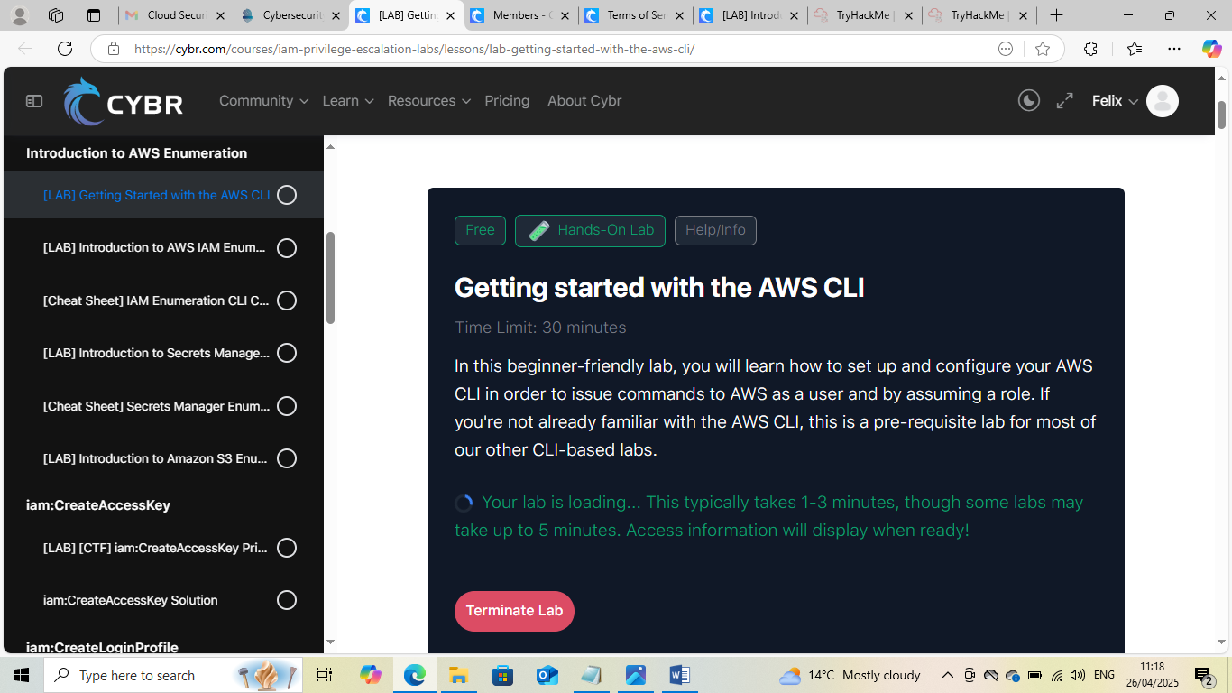

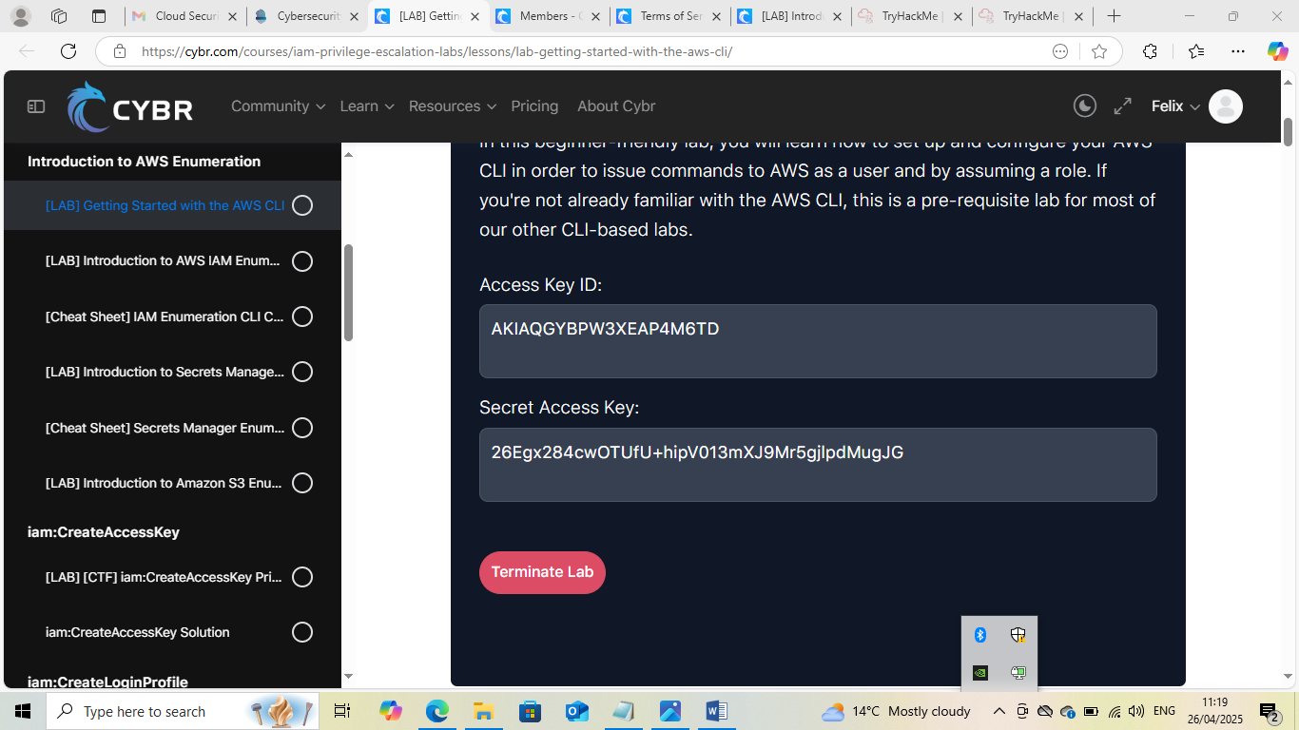

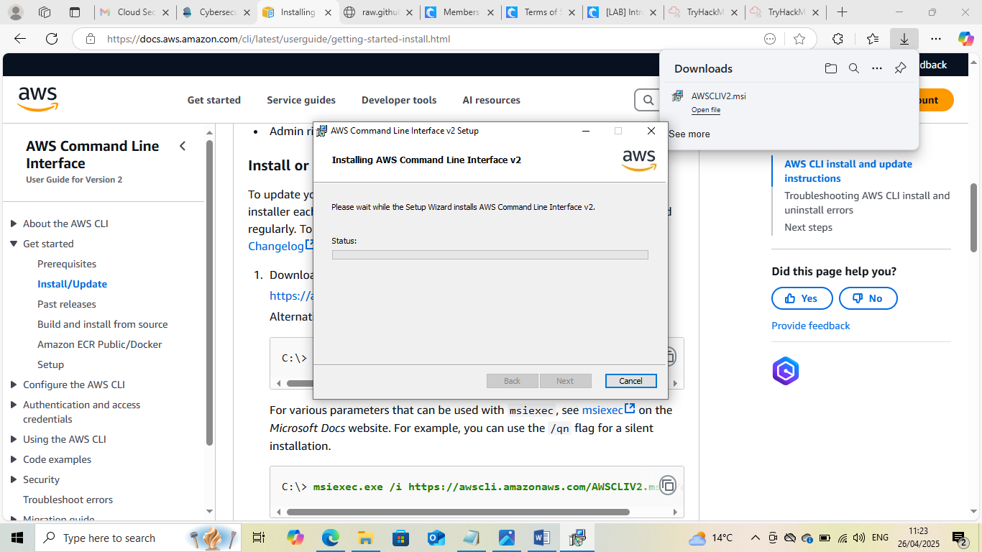

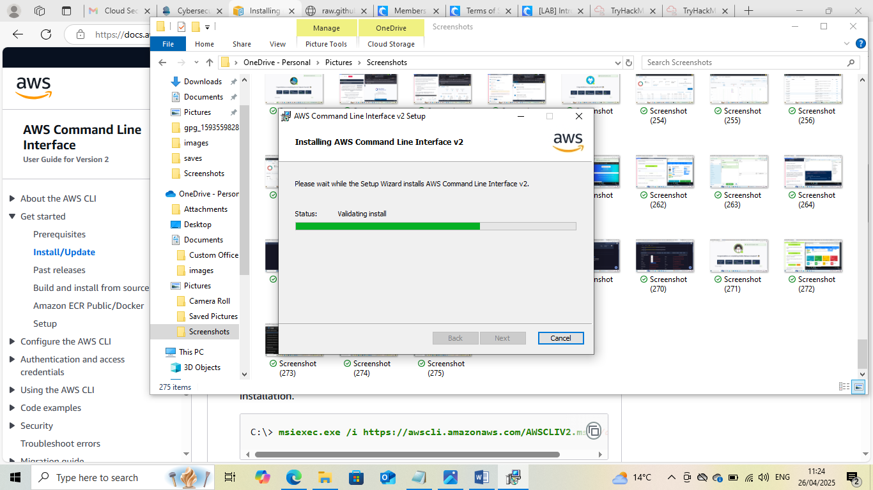

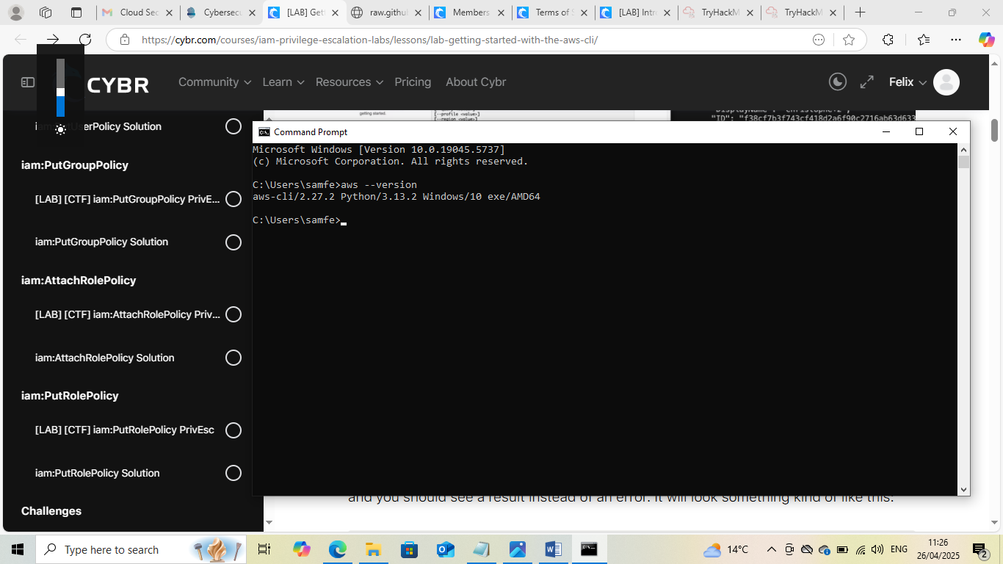

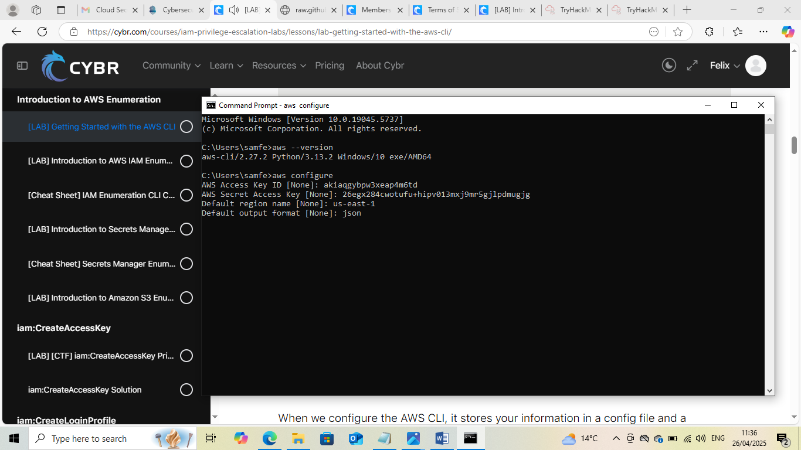

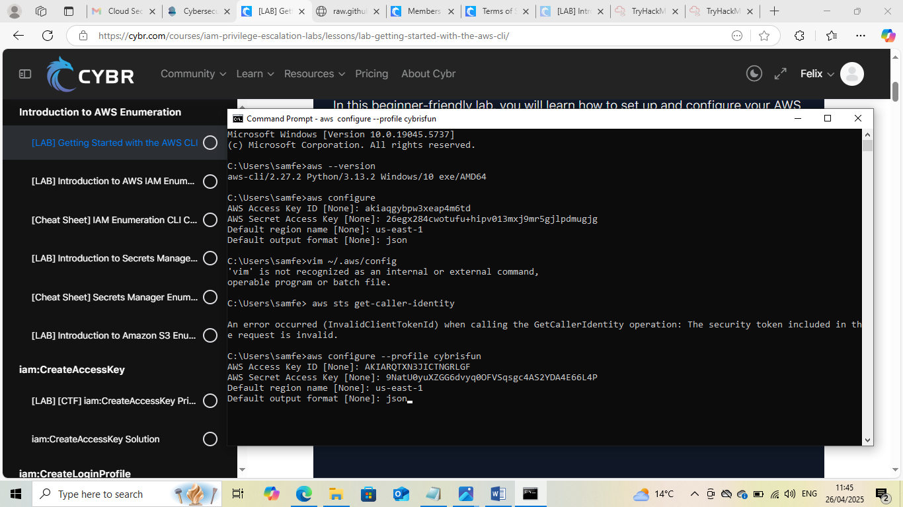

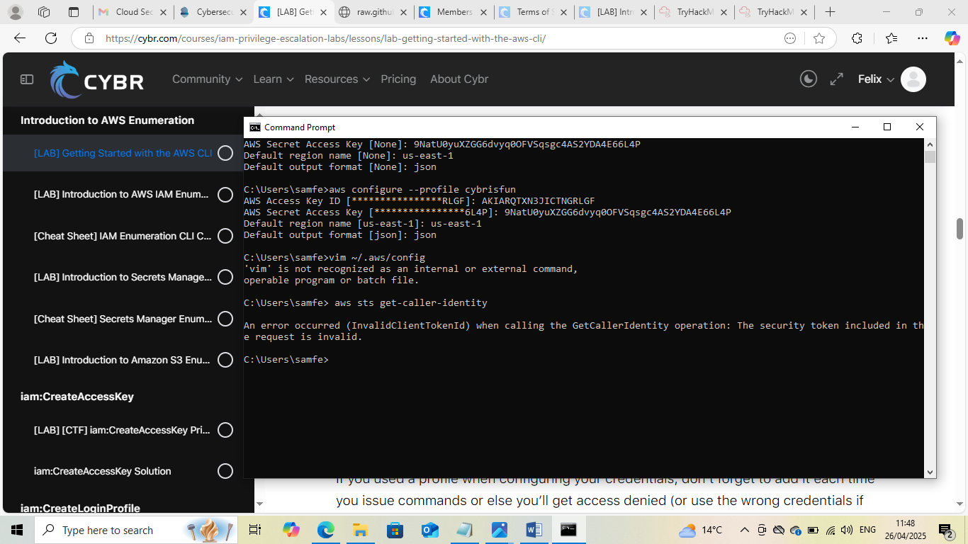

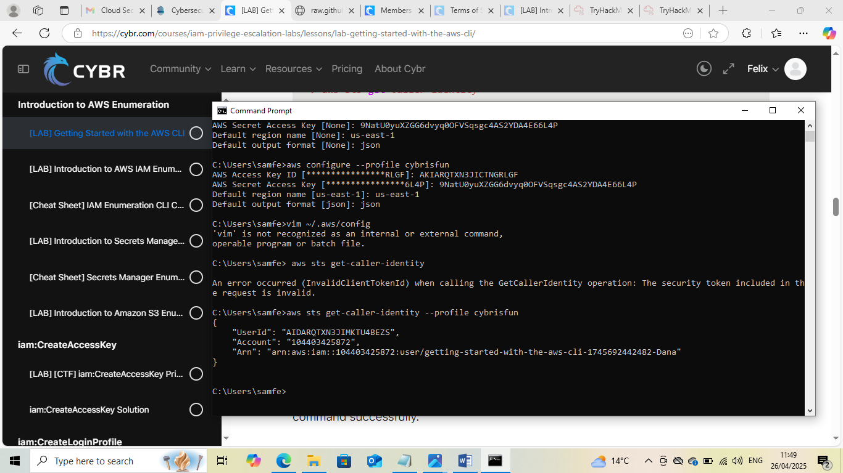

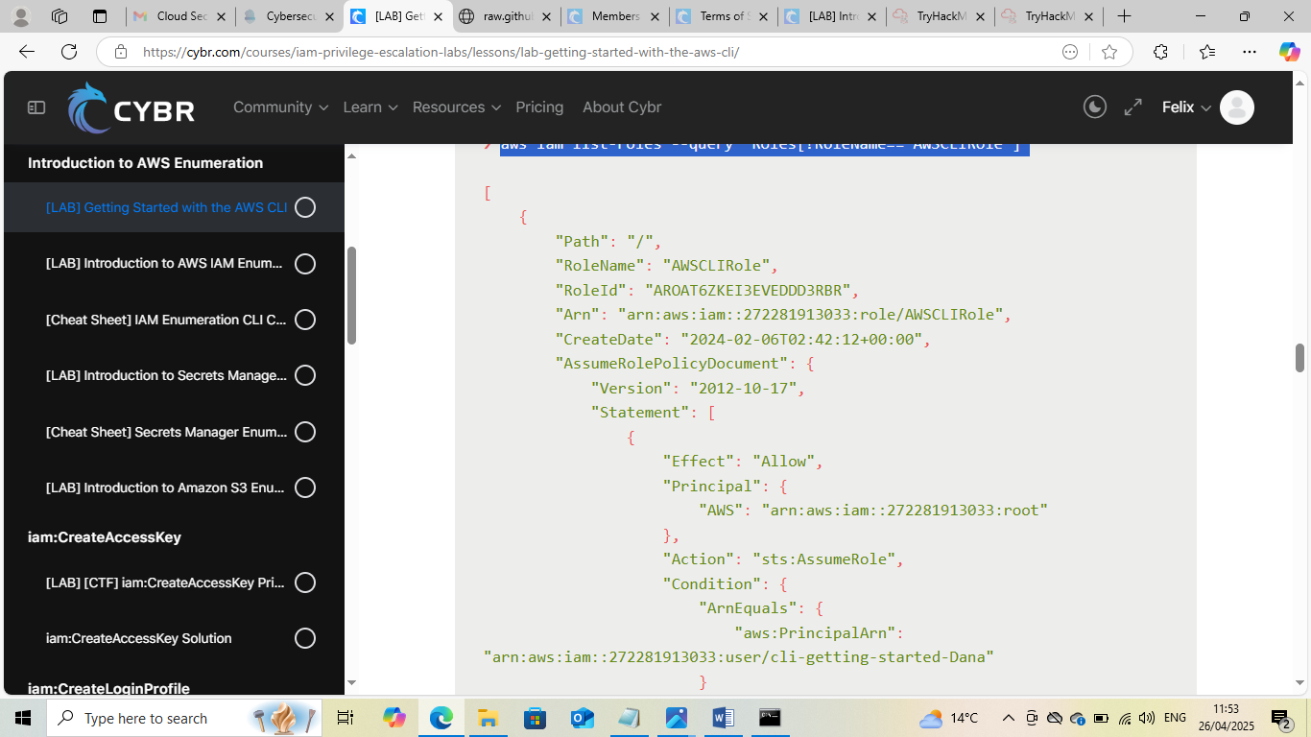

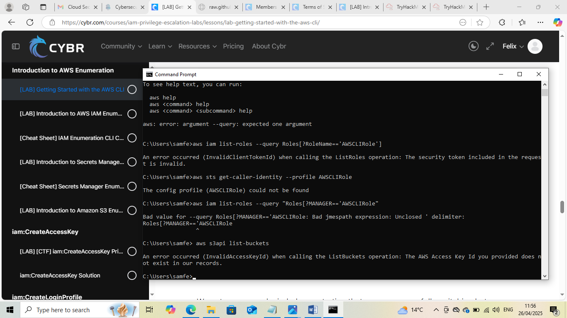

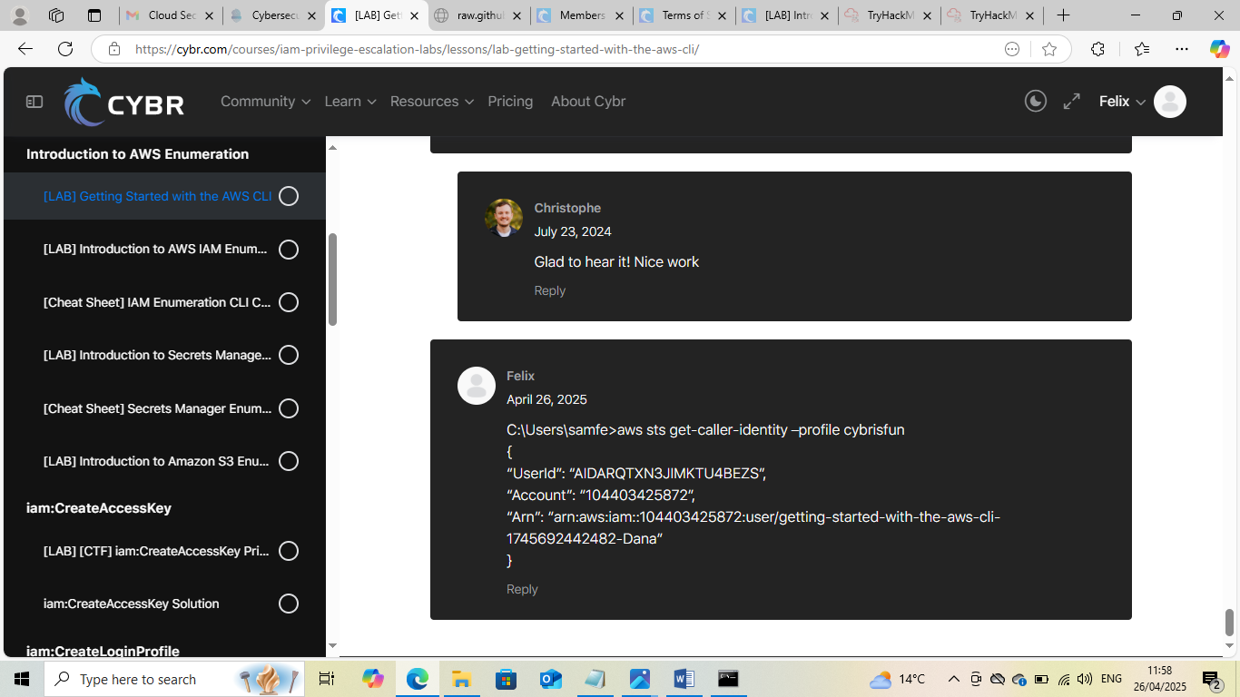

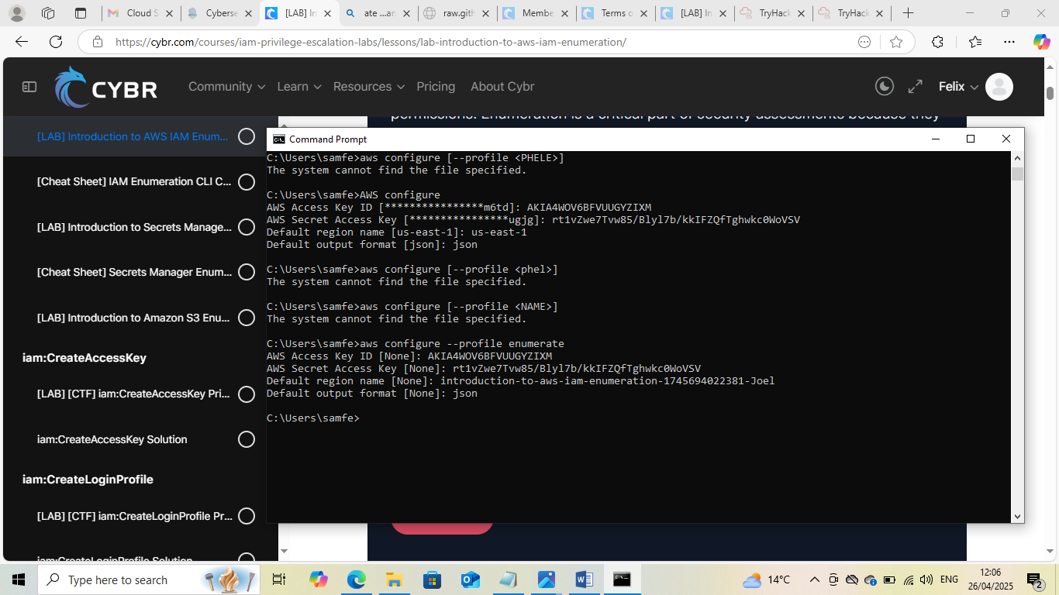

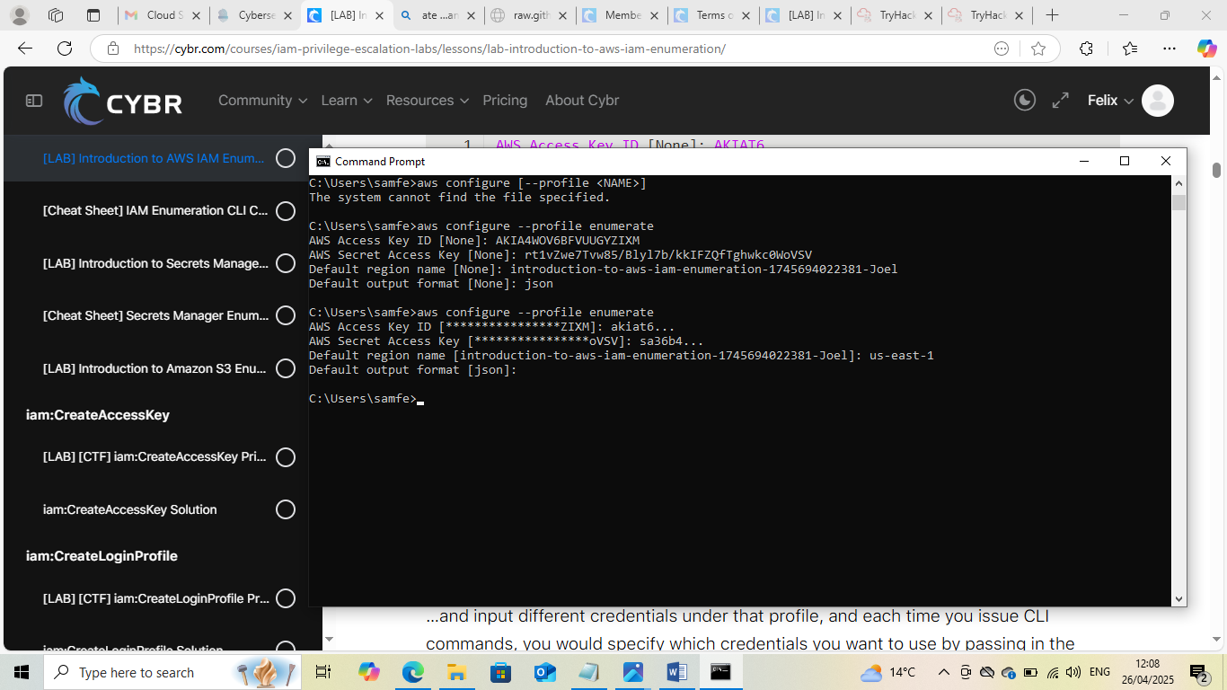

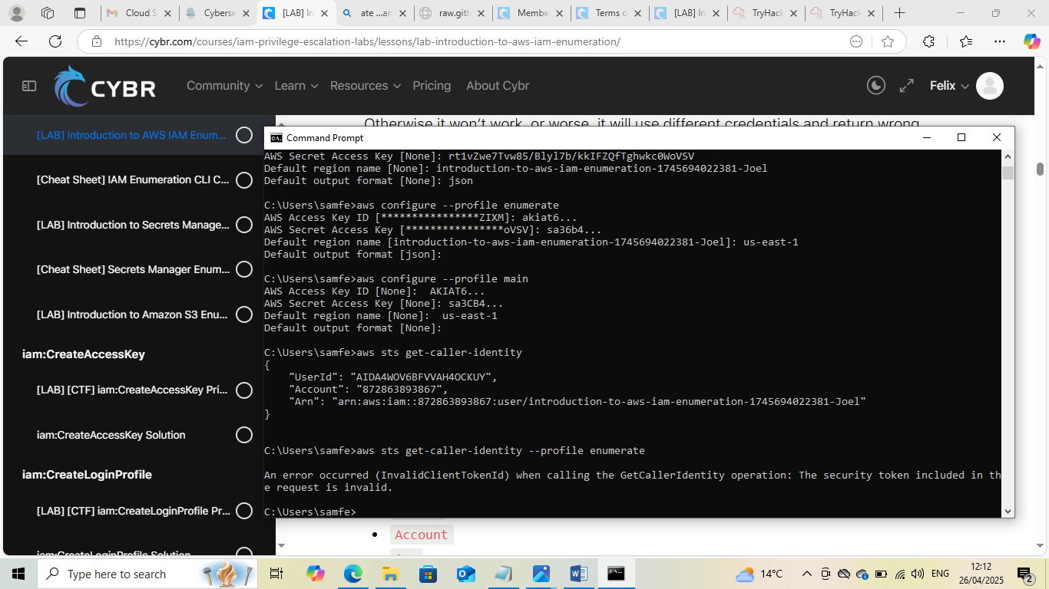

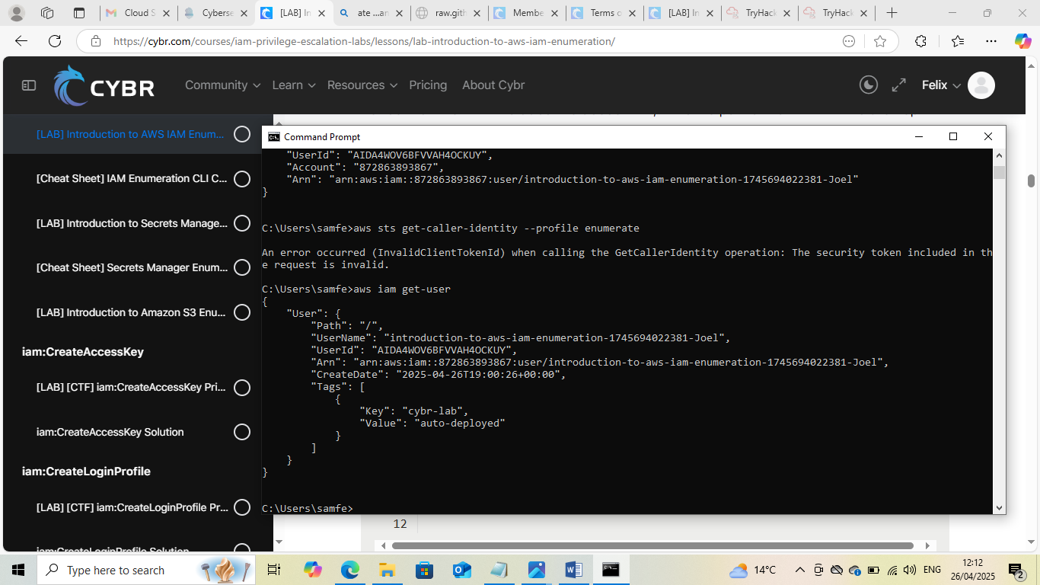
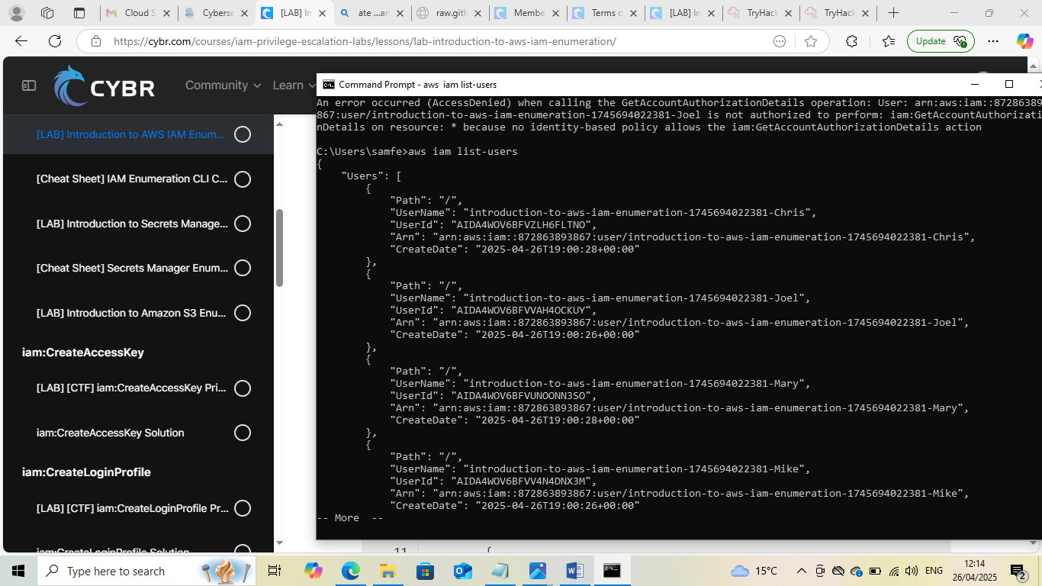

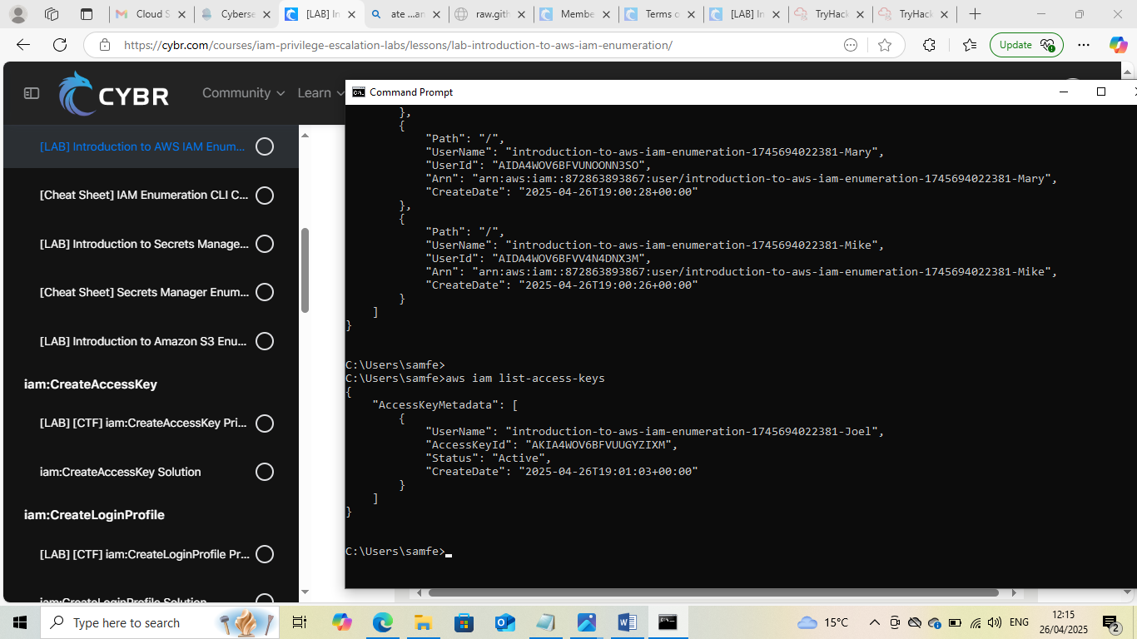
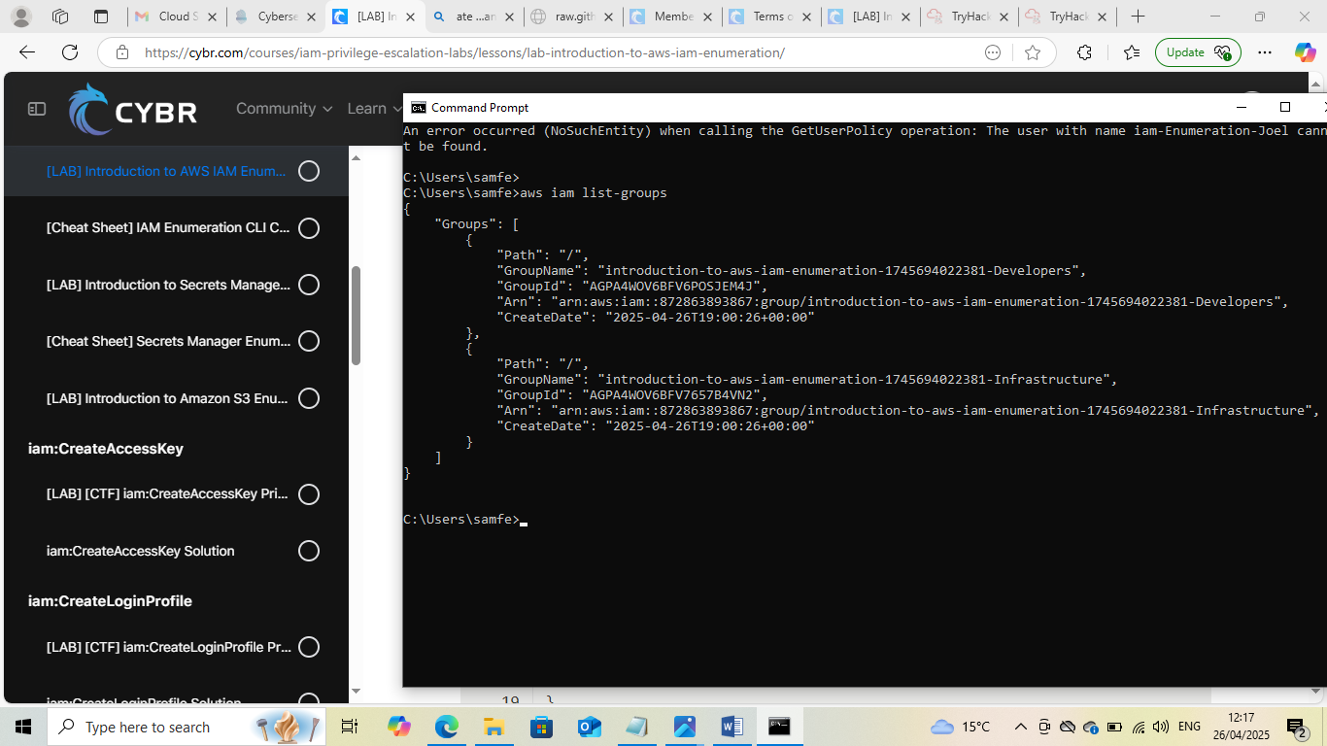

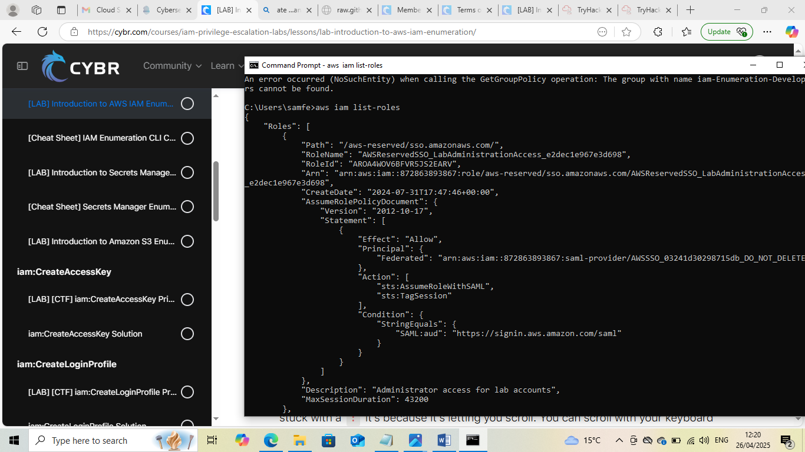
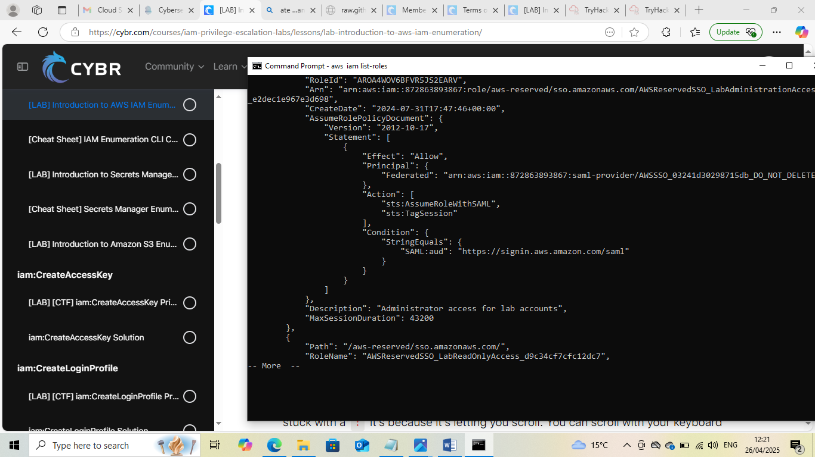

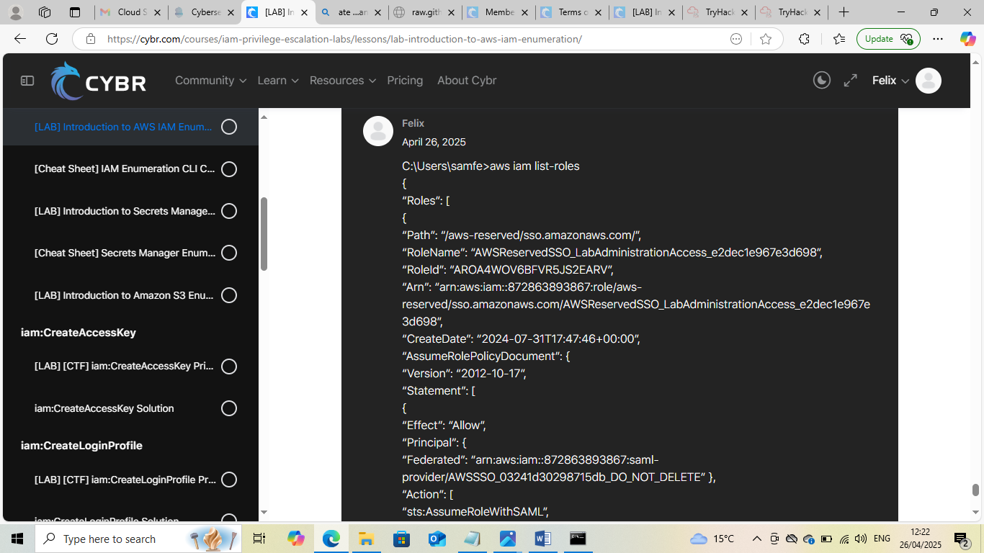
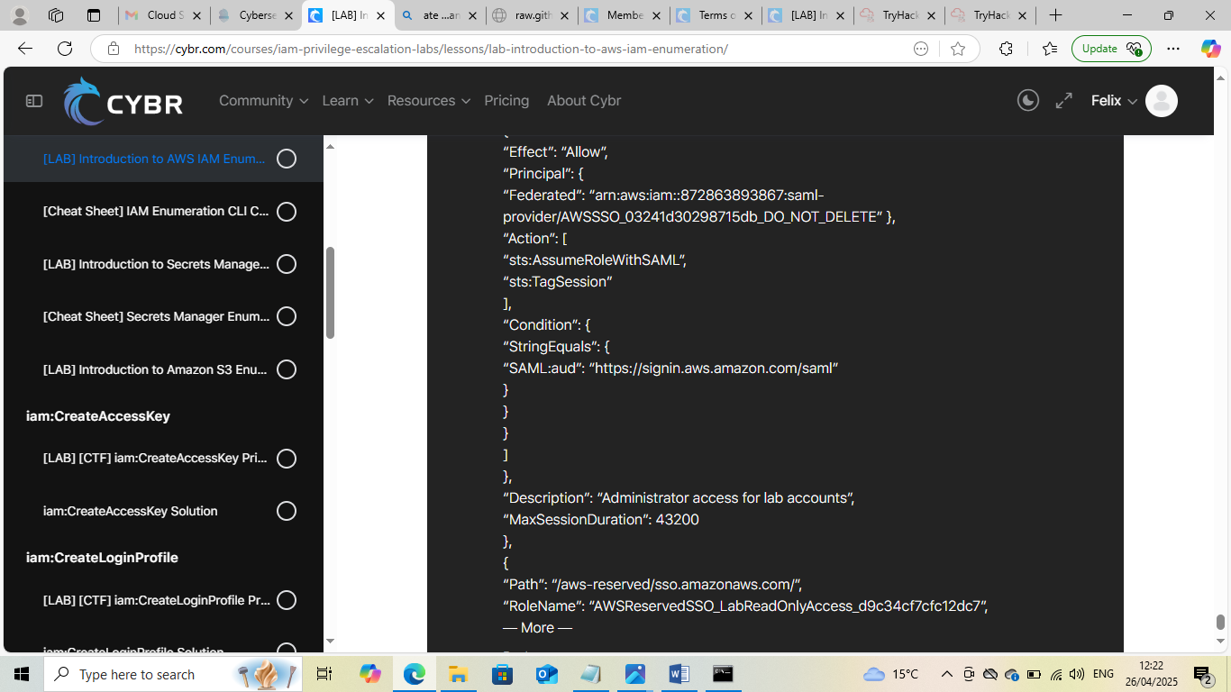

This Internship Task report was developed on [April, 26, 2025]

By:
[ samfelix15@gmail.com ]

